MAIN PAGE
WPC (WOOD PLASTIC COMPOSITE) SIDING & SOFFIT
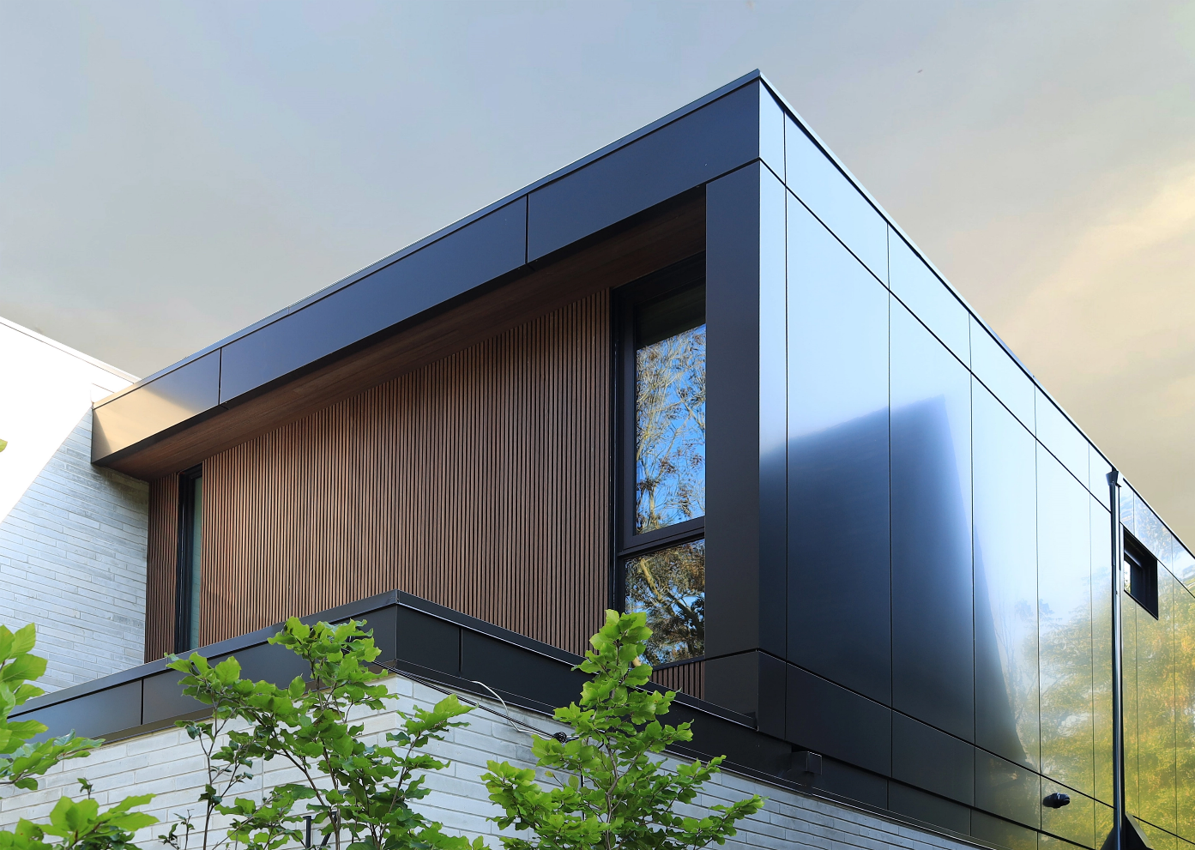
Industrial / Residential / Commercial / Agricultural
WPC Boards — Where Natural Beauty Meets Modern Innovation
WPC board is a type of composite material that combines wood fibers with thermoplastics. Compared to traditional wood products such as MDF boards, WPC boards have many advantages and can be used for various applications.
WPC (Wood Plastic Composite) board is a next-generation material that merges wood fibers with thermoplastics to create a durable, weather-resistant, and low-maintenance solution for a variety of applications. Unlike traditional wood-based products like MDF, WPC offers superior strength, longevity, and adaptability, making it an excellent choice for both interior and exterior projects.

Why Choose WPC?

Built to Last
WPC boards are engineered to resist moisture, rot, warping, and insect damage — making them an ideal choice for demanding environments, from harsh winters to humid summers.

Virtually Maintenance-Free
Forget constant sanding, sealing, and repainting. WPC retains its appearance with minimal upkeep, saving time and maintenance costs over the long term.

Sustainably Engineered
Made from recycled materials, WPC is an environmentally conscious alternative to conventional lumber — without compromising on durability or beauty.

Versatile for Any Project
Whether you’re designing sleek outdoor cladding, stylish indoor wall panels, or functional fencing and decking, WPC delivers consistent performance with a high-end finish.

Enhanced Aesthetics
Thanks to advanced manufacturing techniques, WPC boards replicate the natural grain, warmth, and colour variations of real wood — all while offering a broader selection of tones and finishes that stay vibrant for years.

The Ideal Upgrade to Traditional Wood & MDF
While MDF swells, weakens, and deteriorates in moisture-prone environments, WPC remains stable and reliable, even in exposed exterior conditions. It’s the smart solution for designers, builders, and homeowners who demand more from their materials.
Speak with an Expert Get personalized advice and expert guidance to achieve your project goals with confidence.
WPC SIDING & SOFFIT (PREVIEW)

WPC Fluted Siding & Soffit Panels- ICON
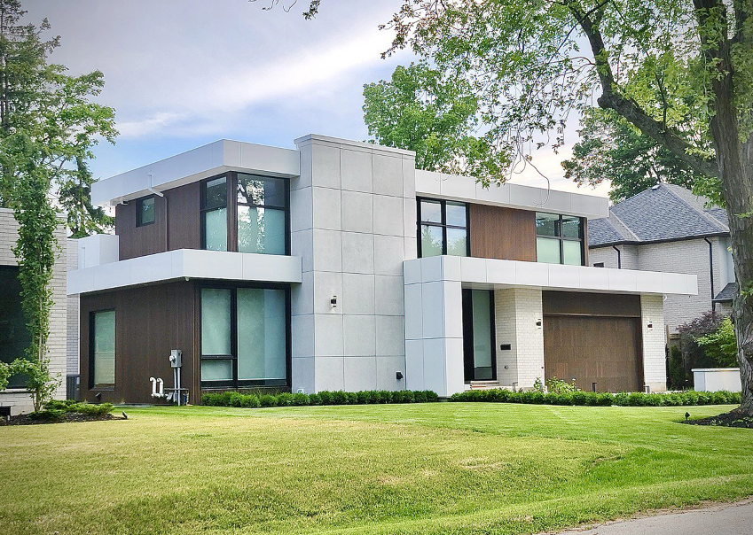
Modern Lines. Natural Feel. Lasting Impact
Elevate your exterior and interior spaces with architectural sophistication that feels both bold and beautifully understated.... (Learn More / Expand)

ENGINEERED WOOD SIDING & SOFFIT (EXPANDED)
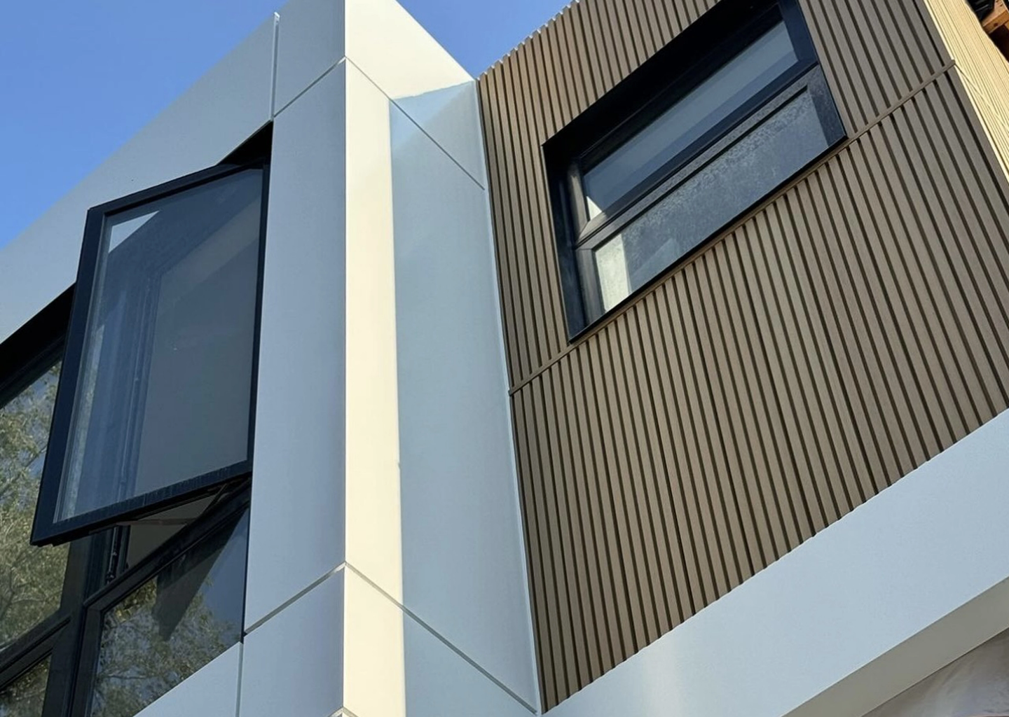
Expanded … Modern Lines. Natural Feel. Lasting Impact
Elevate your exterior and interior spaces with architectural sophistication that feels both bold and beautifully understated. Our Fluted WPC Siding and Soffit Collection introduces a new dimension to cladding design—where structure meets softness, and natural textures meet cutting-edge performance.
Inspired by the clean geometry of Scandinavian design and the enduring warmth of natural timber, these slatted panels deliver a rhythmic texture that creates depth, movement, and elegance across every surface. Whether you’re refreshing a home exterior, designing a dramatic feature wall, or adding texture to soffits and ceilings, fluted cladding makes a confident statement that stays timeless.
Built to replicate the visual impact of parallel castellated timber battens, this line brings shadow, texture, and a tactile richness to your façade—without the limitations of traditional wood. Backed by advanced composite technology, each panel delivers on design while withstanding Canada’s toughest weather conditions with ease.
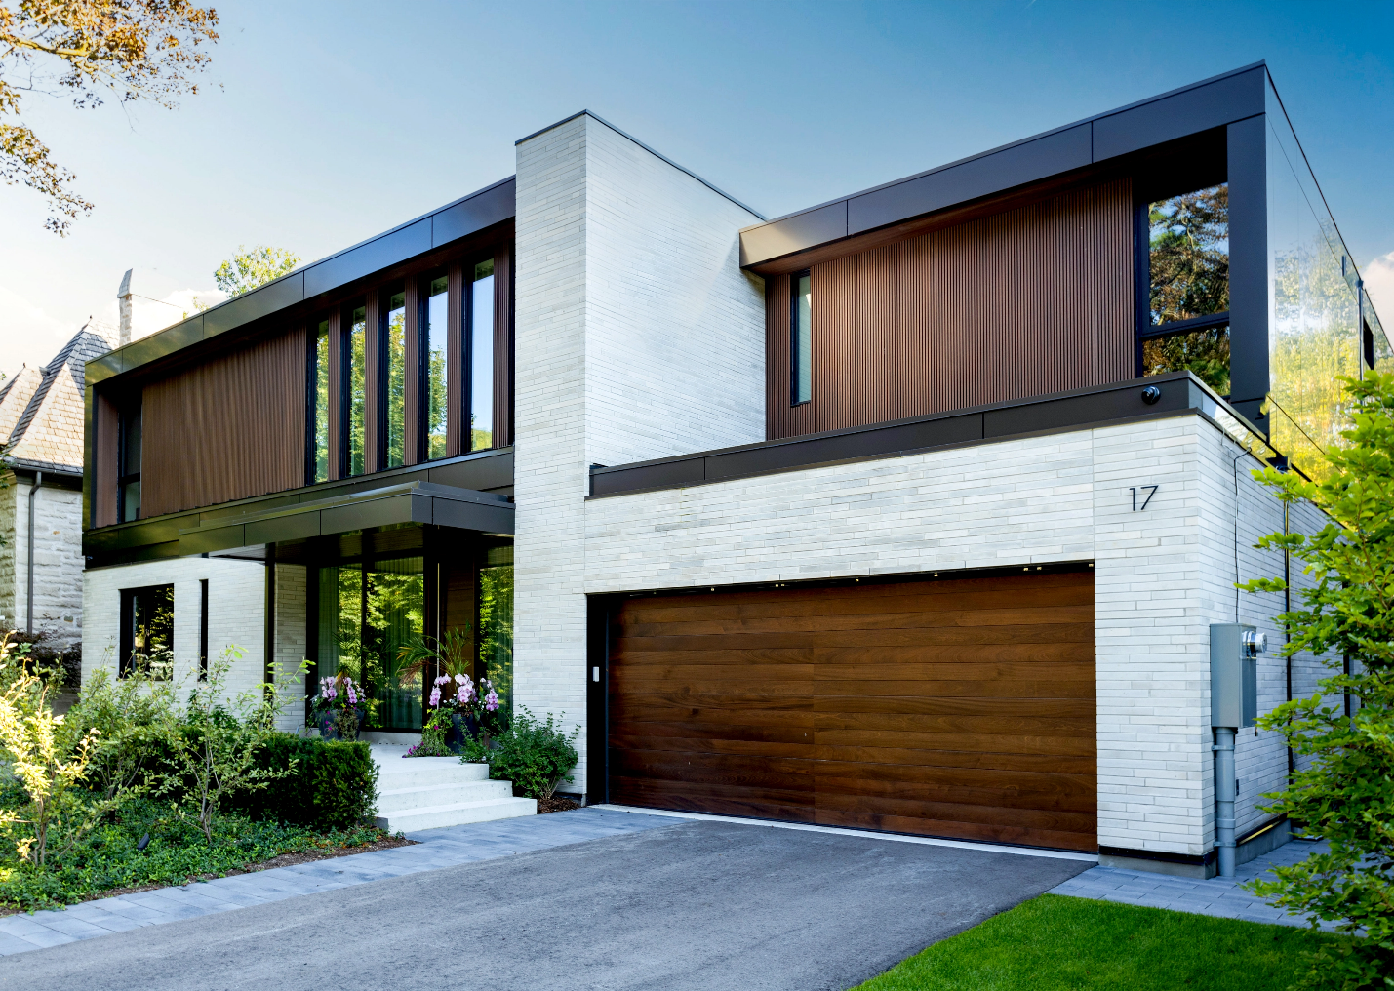
Design & Aesthetic
Modern Minimalism Meets Natural Warmth
Inspired by Nordic design principles, the fluted grooves create a bold ribbed texture that interacts with natural light—adding dynamic movement and layered interest to walls and ceilings throughout the day.
Architectural Shadow Lines
Achieve the look of slender timber battens with clean, repeating lines and recessed grooves that form a subtle yet striking pattern—elevating the visual language of any structure.
The Look of Real Wood, Without the Work
Fluted panels give the appearance of natural timber with no need for sanding, sealing, staining, or repainting. Simply install and enjoy for years to come.

Performance in Canadian Climates
UltraShield® Surface Technology
Built for all seasons—from Ontario’s snow and sleet to BC’s coastal humidity—our panels don’t warp, crack, or lose colour over time.
Low Expansion, High Stability
Designed to maintain form and function with minimal movement, even in high-moisture or high-sun environments.

Key Benefits at a Glance
- Stunning ribbed texture that adds dimension and depth
- Premium wood-look finishes with minimal upkeep
- Suitable for both exterior and interior applications
- Water-resistant, fade-resistant, scratch-resistant
- Made from eco-conscious, fully recyclable materials
- Built for Canadian climate extremes
- Performance in Canadian Climates

Versatile Applications
Fluted panels aren’t just for facades—they’re a powerful design feature for both exterior and interior projects:
- Building facades
- Soffits and ceilings
- Accent walls and screening
- Posts, beams, and columns
- Interior walls, fireplaces, and kitchen islands
- Garage doors, pergolas, and more

Installation Options:
Can be applied vertically, horizontally, or diagonally depending on the look and layout you’re after.
Product Details:
Fluted - CS
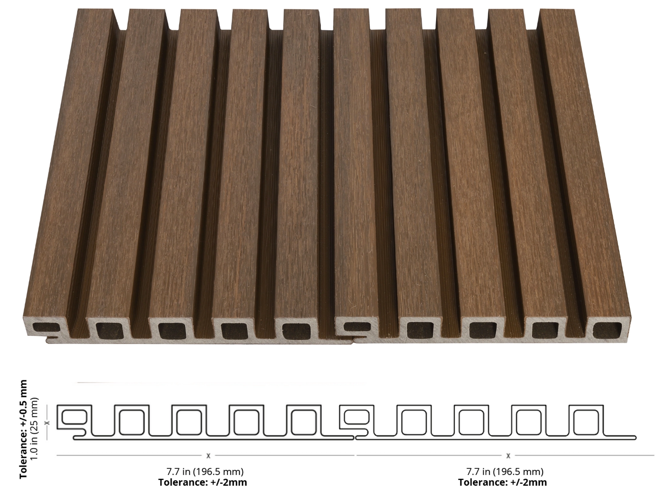

Finish: Brushed
Available Lengths: 10 ft, 12 ft and 16 ft
Profile Dimensions: 7.7” wide × 1.0” thick
Installation Options: Horizontal, Vertical and Soffit applications

Fluted - CL
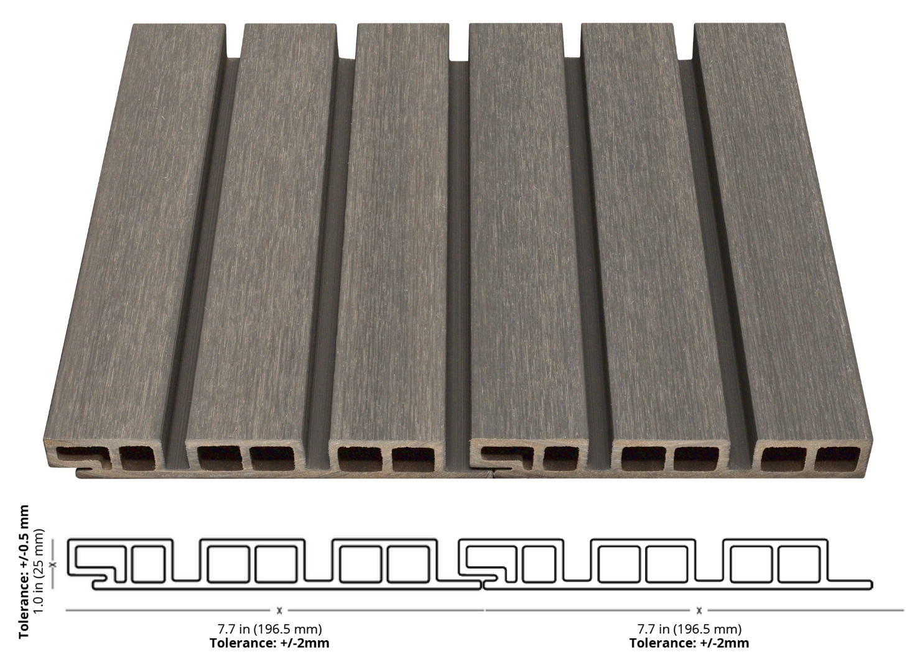

Finish: Brushed
Available Lengths: 10 ft, 12 ft and 16 ft
Profile Dimensions: 7.7” wide × 1.0” thick
Installation Options: Horizontal, Vertical and Soffit applications

Trims
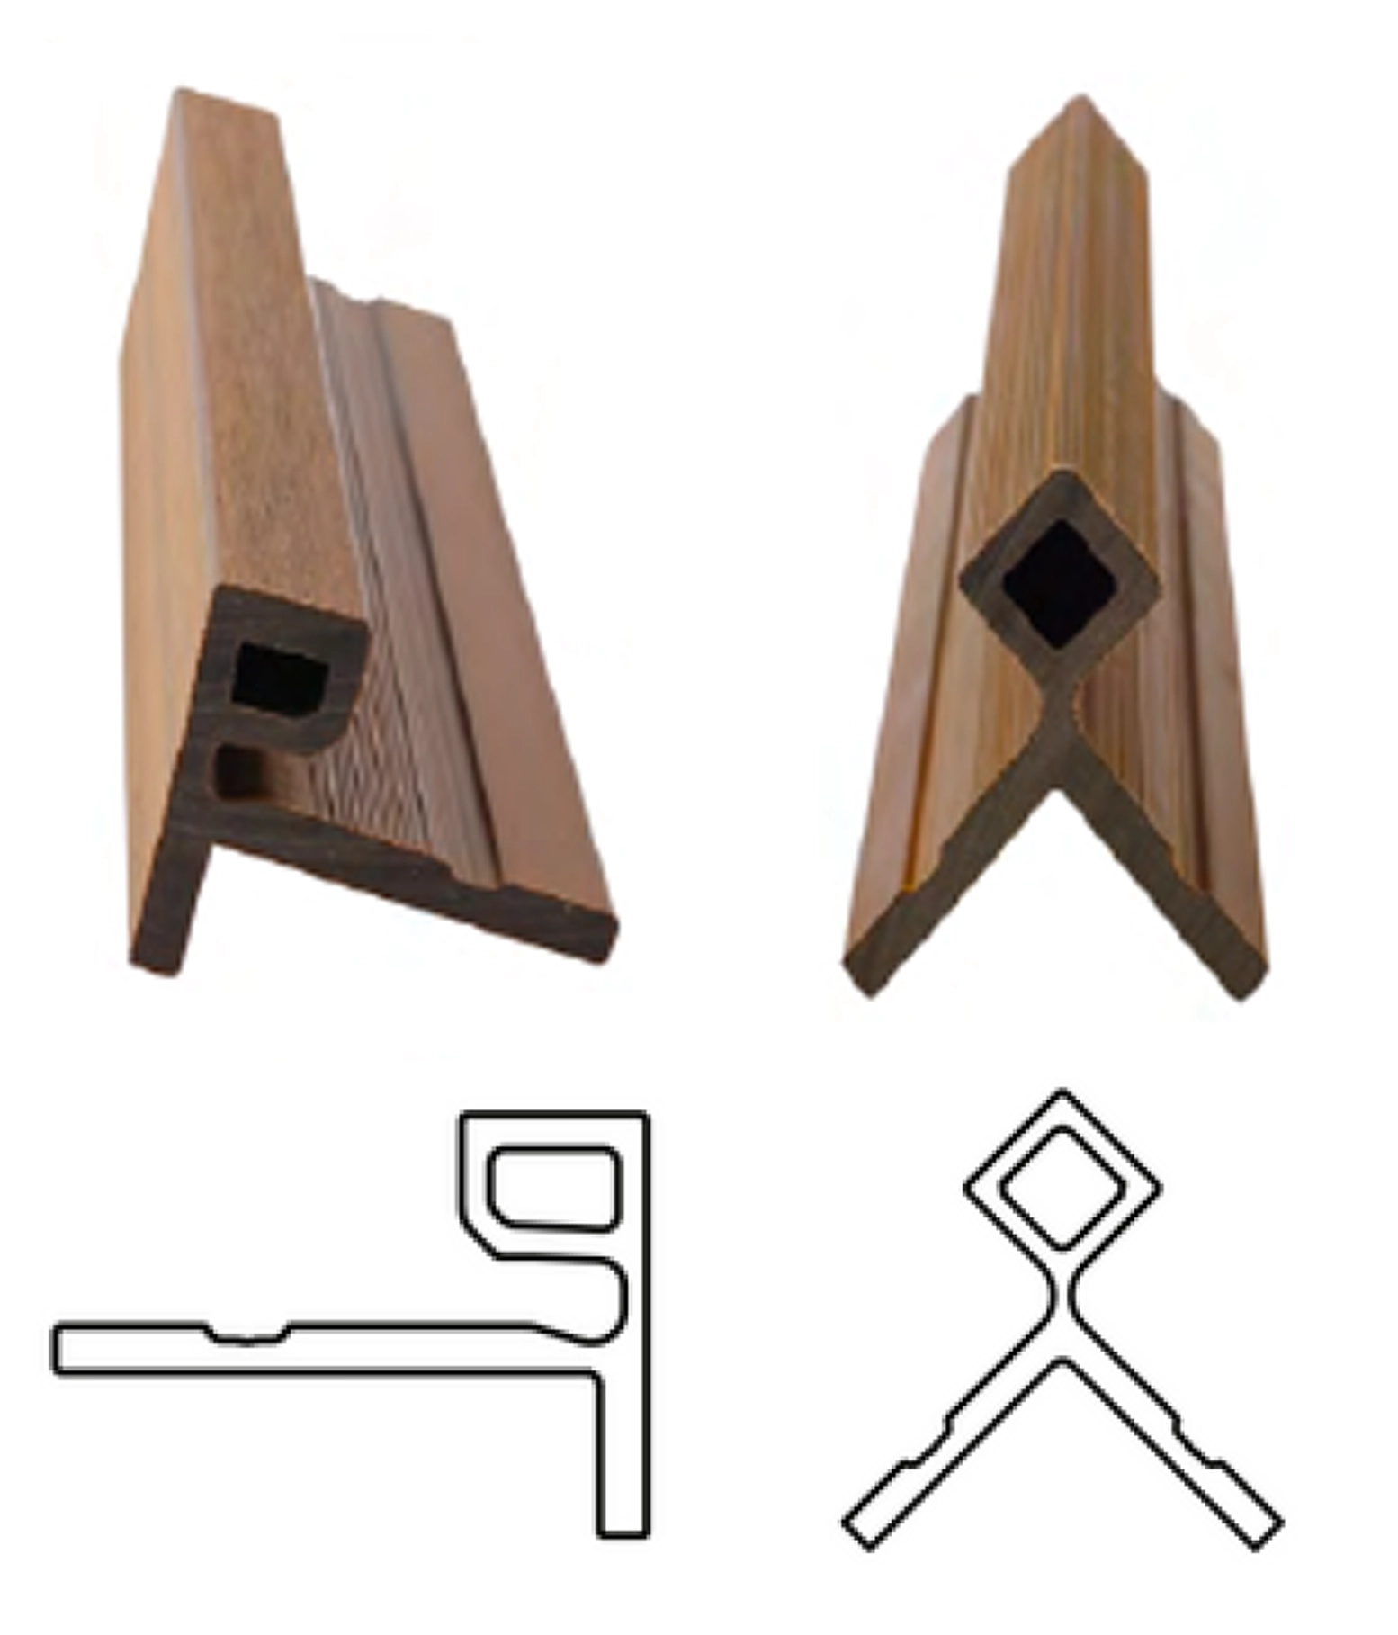
Finish: Brushed
Available Lengths: 10 ft and 16 ft
Finishes & Colour Options
Choose from a thoughtfully curated palette of modern woodgrains and solid tones. All finishes are engineered for durability and visual depth—offered in both smooth and textured variations for added realism and tactile appeal.
